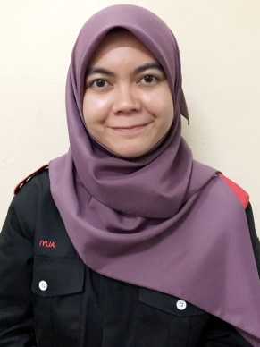



**WORK EXPERINCE**

ADMIN ASSISTANT AT ZALORA MALAYSIA

Responsible to assist in the GST Refund and data entry of the company.



INTERNSHIP

(16 JULY-8 SEPT 2017)

**CONTACT ME**

PARTICIPATE IN DATA ANALATYCAL CHALLENGE

PARTICIPATE IN FREESCALE COMPETITION

**2016**

**2013-2015**

**PRESENT**

VICE PRESIDENT OF “PERSATUAN MAHASISWA KEJUEUTERAANELEKTRIK”

VICE CHANCELLOR AWARD

Diploma of Electrical Engineering at Mara University of Technology

**SKILL**

**CURRICULUM**

**AWARDS**

**P :E :A :**

+6019-753 2833hashimah655@salam.uitm.edu.comMara University of Technology, Shah Alam

IR.DR HASHIMAH HASHIM

LECTURER

**REFERENCE**

**TEAM WORK**

**MS OFFICE**

**ARDUINO**

**CREATIVITY**

**CODE BLOCK**

**MICROWIND**

**LTSPICE**

**MINITAB**

**PROTEUS**

**ENGLISH**

**MALAY**

+60 12 241 4191

No. 53 Jalan Bm 2/22 Seksyen 2, Bandar Bukit Mahokota, Bangi

43000 Kajang.

iyliaadhwa@gmail.com

**2015**

**2015**

Diploma of Electrical Engineering at Mara University of Technology

BEST GRADUATE AWARD PROGRAM

SIJIL PELAJARAN MALAYSIA (SPM)

SEKOLAH MENEGAH TEKNIK GOMBAK, SELANGOR

6A4B.

**2000-2004**

**2012-2015**

Mara University Of Technology, Shah Alam

CGPA: 3.89/4.00

DIPLOMA IN ELECTRICAL ENGINEERING

BACHELOR OF ELECTRONIC ENGINEERING

Mara University Of Technology, Shah Alam

CURRENT CGPA:3.85/4.00

**EDUCATION**

**2015-Present**

IYLIA ADHWA MAZNI

**2015**

**PROFILE**

Highly creative and multitalented Graphic Designer with extensive experience in multimedia, marketing and print design. Exceptional collaborative and interpersonal skills; dynamic team player with well-developed written and verbal communication abilities. Highly skilled in client and vendor relations and negotiations. Passionate and inventive creator of innovative marketing strategies and campaigns; accustomed to performing in deadline-driven environments with an emphasis on working within budget requirements.

**SKILL**